Higher Order Thinking MC Questions

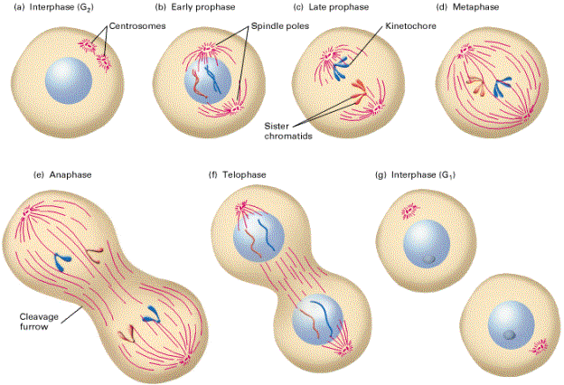
The illustration above shows the process of meiosis. The questions that follow will be answered by gathering and interpreting information from this illustration.

- According to meiosis, what are the functions of the spindle fibers?
A. Fixes the organelles to the side of the cell during meiosis
B. Replicate each strand of DNA within the nucleus
C. Arrange the cell to prepare for replication
D. Attach and separate the homologous chromosomes
E. Restores the nuclear membrane around the genetic material

- What would happen if the nuclear membrane did not disappear?
A. The spindle fibers would not be able to reach the chromosomes
B. Meiosis would be able to continue without the genetic material
C. The cell would not be able to separate at the end of meiosis
D. Chromosomes would be able to cross the membrane to continue meiosis
E. The centrioles would not produce any spindle fibers for attachement

- During the stage of Telophase (f), what process is the cell undergoing to split in two?
A. Crossing-over
B. Cytokinesis
C. Tetrad formation
D. Spindle fibers attach
E. Chromosome separation

